Practical 4

The geometry of solutions of a system of linear equations.
import numpy as np
import matplotlib.pyplot as plt

# Define the coefficients of the system of equations:
# Example system:
# 2x + y = 5
# x - y = 1

# Coefficients matrix A
A = np.array([[2, 1],
[1, -1]])

# Constants vector B
B = np.array([5, 1])

# Solve the linear system
solution = np.linalg.solve(A, B)
x_sol, y_sol = solution

print(f"Solution: x = {x_sol}, y = {y_sol}")

# Plotting the lines to show geometry of solution
x = np.linspace(-1, 5, 400)

# Lines from the system
y1 = (5 - 2*x) # From 2x + y = 5 => y = 5 - 2x
y2 = x - 1 # From x - y = 1 => y = x - 1

plt.plot(x, y1, label="2x + y = 5")
plt.plot(x, y2, label="x - y = 1")

# Plot the solution point
plt.plot(x_sol, y_sol, 'ro', label="Solution")

plt.xlabel('x')
plt.ylabel('y')
plt.title('Geometry of Solutions of Linear Equations')
plt.legend()
plt.grid(True)
plt.show()

output:

Solution: x = 2.0, y = 1.0

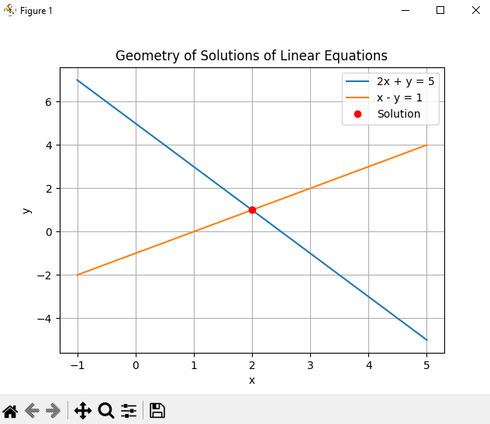

5 Simple Python Program: Determinant and Rank of a Matrix
import numpy as np

# Example Matrix
A = np.array([[2, 3, 1],
[4, 1, -1],
[1, -2, 5]], dtype=float)

print("Matrix A:")
print(A)

# Determinant
detA = np.linalg.det(A)
print("\nDeterminant of A =", detA)

# Rank
rankA = np.linalg.matrix_rank(A)
print("Rank of A =", rankA)

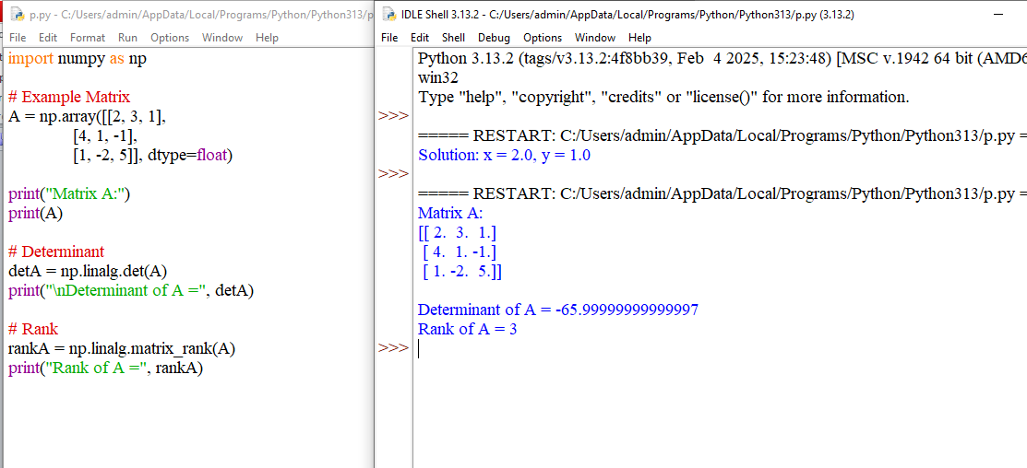

Practical 6
Python program for solving a system of linear equations using determinants.
import numpy as np

def solve_using_determinants(A, B):
"""
Solves the system A·x = B using Cramer's Rule.
A: coefficient matrix (n×n)
B: constants vector (n)
"""
A = np.array(A, dtype=float)
B = np.array(B, dtype=float)

det_A = np.linalg.det(A)

if det_A == 0:
raise ValueError("Determinant of A is zero. System has no unique solution.")

n = A.shape[0]
solutions = []

for i in range(n):
Ai = A.copy()
Ai[:, i] = B # Replace column i with constants vector
det_Ai = np.linalg.det(Ai)
solutions.append(det_Ai / det_A)

return solutions

# Example: Solve the system
# 2x + 3y - z = 5
# 4x + y + 2z = 6
# -2x + 5y + 3z = 1

A = [
[2, 3, -1],
[4, 1, 2],
[-2, 5, 3]
]

B = [5, 6, 1]

solution = solve_using_determinants(A, B)

print("Solution:")
for i, val in enumerate(solution):
print(f"x{i+1} = {val}")

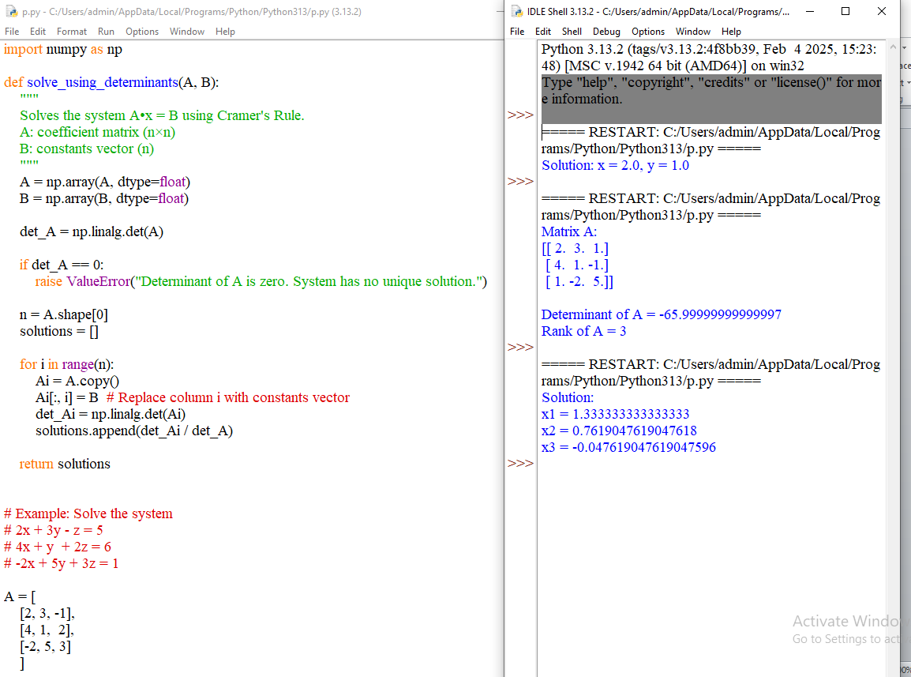

7.python program on Elementary matrices and their relations with elementary operations on matrices.
import numpy as np

# Original matrix
A = np.array([
[1, 2, 3],
[4, 5, 6],
[7, 8, 9]
], float)

print("Original Matrix A:\n", A, "\n")

# --- Elementary Matrix 1: Swap R1 and R2 ---
E1 = np.array([
[0, 1, 0],
[1, 0, 0],
[0, 0, 1]
], float)

print("E1 (Swap R1 and R2):\n", E1)
print("E1 * A:\n", E1 @ A, "\n")

# --- Elementary Matrix 2: Multiply R2 by 3 ---
E2 = np.array([
[1, 0, 0],
[0, 3, 0],
[0, 0, 1]
], float)

print("E2 (Multiply R2 by 3):\n", E2)
print("E2 * A:\n", E2 @ A, "\n")

# --- Elementary Matrix 3: R3 → R3 - 2R1 ---
E3 = np.array([
[1, 0, 0],
[0, 1, 0],
[-2, 0, 1]
], float)

print("E3 (R3 = R3 - 2R1):\n", E3)
print("E3 * A:\n", E3 @ A, "\n")

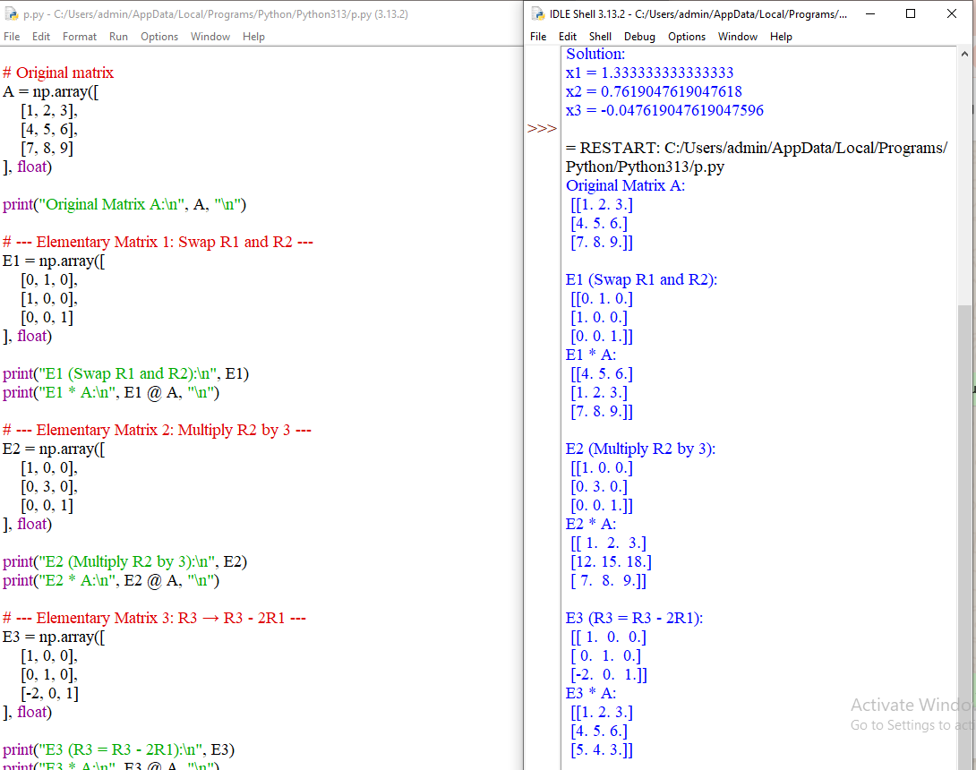

8.Python Program on Invertibility of Elementary Matrices
import numpy as np

# ------- Elementary Matrices -------

# 1. Row swap R1 ↔ R2
E1 = np.array([
[0, 1, 0],
[1, 0, 0],
[0, 0, 1]
], float)

# 2. Multiply R2 by 3
E2 = np.array([
[1, 0, 0],
[0, 3, 0],
[0, 0, 1]
], float)

# 3. Add 2 times R1 to R3 → R3 = R3 + 2R1
E3 = np.array([
[1, 0, 0],
[0, 1, 0],
[2, 0, 1]
], float)

# ------- Check invertibility -------

print("E1:\n", E1)
print("Inverse of E1:\n", np.linalg.inv(E1), "\n")

print("E2:\n", E2)
print("Inverse of E2:\n", np.linalg.inv(E2), "\n")

print("E3:\n", E3)
print("Inverse of E3:\n", np.linalg.inv(E3), "\n")

